承认书

Specification for approval
客户名称(Customer name)：

经办者(Director)：

职称(title)：

客户料号(Customer part NO)：

版本(Revision)： A.0

发件日期(Issue date)： 2018-12-06

回文日期(Return date)：

一、谨致执事者：兹提供敝公司产品之有关详细规格及图面数据，敬请给予办理测试认定手续，
同时敬请送返一份附有贵公司签认之测试认定后之样品认定书。
（We are please in sending you herewith our specification and drawings for your approval. ）
（Please return to us one copy “For Approval” with your approved signatures.）
二、附件(Accessory):
□样品 □出货检验记录表 □封装尺寸图 £电气特性曲线
£内部线路图 £焊性建议 £PAD建议 £包装方式
三、客户意见栏(Customer’s Proposal)
£ 同意(Agree)：(请于认可栏中签名)
£ 不同意(Disagree)：
原因(Reason)：
客户认可签章(Customer Signature):

- 产品描述/ Features
- 外观尺寸/ Package ( L/W/H ) : 2.0*1.25*0.85 mm
- 颜色/ Color: 橙光 / Orange light
- 胶体/ Lens: 透明平面胶体/ Transparent planar colloid
- EIA规范标准包装/ EIA STD Package
- 环保产品，符合ROHS要求/ Meet ROHS, Green Product
- 适用于自动贴片机/ Compatible With SMT Automatic Equipment
适用于红外线回流焊制程/ Compatible With Infrared Reflow Solder Process

2 . 外形尺寸及建议焊盘尺寸/ Package Profile & Soldering PAD Suggested

注/ Notes: 1. 单位 : 毫米（mm）/ All dimensions are in millimeters
2. 公差 ：如无特别标注则为± 0.1 mm Tolerance is ± 0.10 mm unless otherwise noted

3. 建议焊接温度曲线 / Soldering Profile Suggested

4. 最大绝对额定值/ Absolute Maximum Ratings （Ta=25℃）
参 数/ Parameter | 符号Symbol | 最大额定值/ Rating |  | 单 位/ Unit
消耗功率/ Power Dissipation | Pd | 40 |  | mW
最大脉冲电流/ Peak Forward Current  (1/10占空比, 0.1ms脉宽) | IFP | 60 |  | mA
正向直流工作电流/ DC Forward Current | IF | 25 |  | mA
反向电压/Backward Voltage | VR | 5 |  | V
工作温度范围  Operating Temperature Range | Topr | -40°C ~ + 85°C
存储温度范围  Storage Temperature Range | Tstg | -40°C ~ + 85°C
焊接条件  Soldering Condition | Tsol | 回流焊/ Reflow soldering : 260°C ，10s  手动焊/ Hand soldering : 300°C ，3s
抗静电能力  Electrostatic Discharge | ESD |  | V
5.光电参数/ Electrical Optical Characteristics （Ta=25℃）
参数  Parameter | 符号  Symbol | 最小值  Min. | 代表值  Typ. | 最大值  Max. | 单位  Unit | 测试条件  Test Condition
光强  Light Intensity | IV | 70 | -- | 175 | mcd | IF = 20mA
半光强视角  Viewing Angle | 2θ1/2 | --- | 120 | --- | deg | IF = 20mA
主波长  Dominant Wavelength | λd | 598 |  | 608 | nm | IF = 20mA
峰值波长  Peak Wavelength | λp | 600 |  | 612 | nm | IF = 20mA
正向电压  Forward Voltage | VF | 1.8 |  | 2.4 | V | IF = 10mA
反向电压  Backward Voltage | IR | --- | --- | 5 | μA | VR = 5V
半波宽  Spectral Line Half-Width | Δλ |  | 20 |  | nm | IF = 20mA

- 光电参数分BIN规格/Photoelectric parameters are divided into BIN sprcifications
6.1.亮度分BIN规格/Bin Range of Luminous Intensity
Bin | Min | Max | Unit | Condition
P18 | 70 | 85 | MCD | IF =20mA
P19 | 85 | 100 | MCD | IF =20mA
P20 | 100 | 120 | MCD | IF =20mA
P21 | 120 | 145 | MCD | IF =20mA
P22 | 145 | 175 | MCD | IF =20mA
Notes: Tolerance of Luminous Intensity: ± 10%

6.2.电压分BIN规格/ Bin Range of Forward Voltgae
Bin | Min | Max | Unit | Condition
VE | 1.8 | 1.9 | V | IF = 20mA
VF | 1.9 | 2.0 | V | IF = 20mA
VG | 2.0 | 2.1 | V | IF = 20mA
VH | 2.1 | 2.2 | V | IF = 20mA
VI | 2.2 | 2.3 | V | IF = 20mA
VJ | 2.3 | 2.4 | V | IF = 20mA
Notes: Tolerance of Forward Voltage: ± 0.05V

6.3.波长分BIN规格/ Bin Range of Wavelength
Bin | Min | Max | Unit | Condition
O2 | 598 | 600 | NM | IF = 20mA
O3 | 600 | 602 | NM | IF = 20mA
O4 | 602 | 604 | NM | IF = 20mA
O5 | 604 | 606 | NM | IF = 20mA
O6 | 606 | 608 | NM | IF = 20mA
Notes: Tolerance of Wavelength: ± 1nm

7.光电参数代表值特征曲线/ Typical Electrical-Optical Characteristics Curves
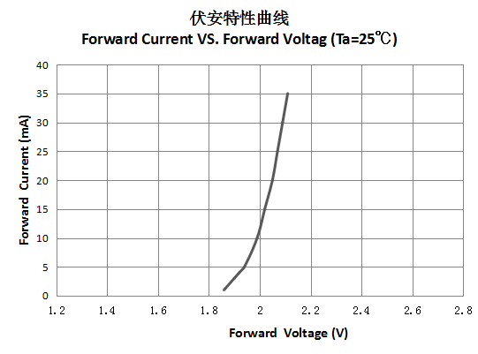

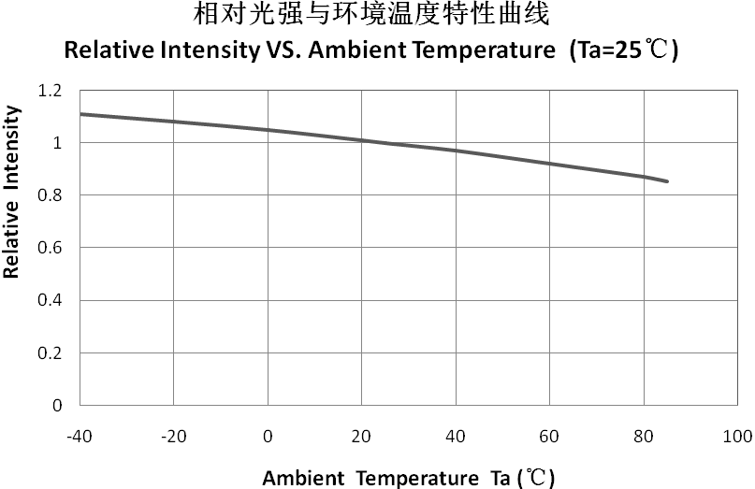
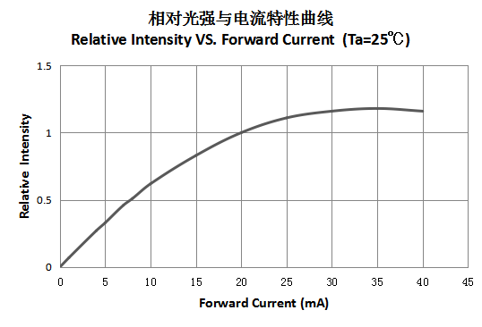

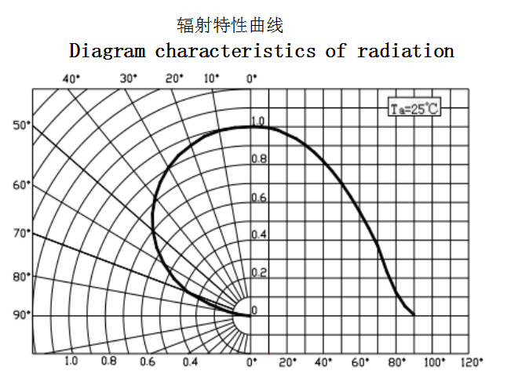
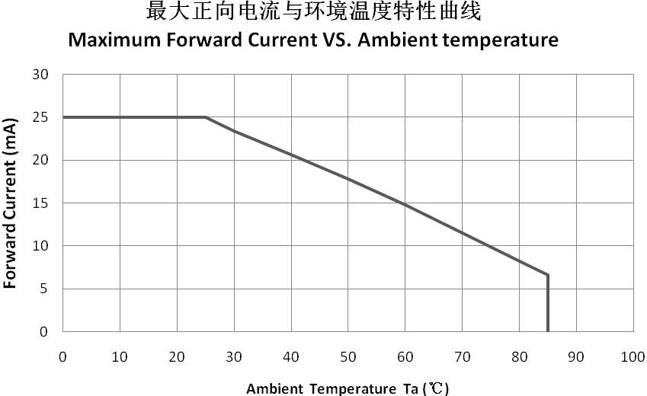

8.包装载带与圆盘尺寸/ Reel And Tape Dimensions
包装数量：3000 pcs/卷 Packing quantity: 3000 PCS/rolls

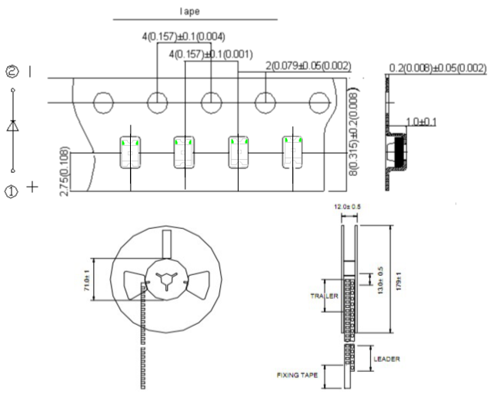

注/ Notes: 1. 尺寸单位为毫米(mm)/ All dimensions are in millimeters.
2. 尺寸公差是±0.1mm/ Tolerance is ± 0.1 mm unless otherwise noted.
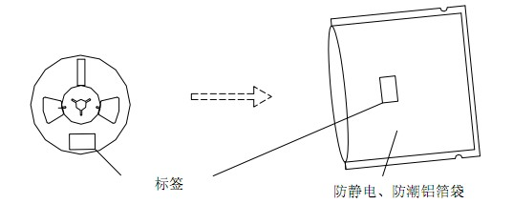
9.标签及标识/ Label Explanation：

The label Anti-static, moisture-proof aluminum foil bag

10.信赖性测试项目及条件/Reliability Test Items And Conditions
测试项目  Test Item | Ref.Standard  参考标准 | Test Condition  测试条件 | Time  时间 | Quantity  数量 | Accepted/Rejected  接收/拒收
Reflow  回流焊 | JESD22-B106 | Temp:255℃max  T=10 sec | 2times | 22 | 0/1
Thermal Shock  冷热冲击 | JESD22-A106 | -40℃ 15min  ↑↓  100℃ 15min | 300 cycles | 22 | 0/1
High Temperature Storage  高温保存 | JESD22-A103 | Temp:100℃ | 1000Hrs. | 22 | 0/1
Low Temperature Storage  低温保存 | JESD22-A119 | Temp:-40℃ | 1000Hrs. | 22 | 0/1
Life Test  常温通电 | JESD22-A108 | Ta=25℃  IF=5mA | 1000Hrs. | 22 | 0/1
High Temperature /  High Humidity  高温高湿 | Qiangsq831 | 85℃/ 85%RH | 1000Hrs. | 22 | 0/1
失效判定标准 Criteria For Judging Damage
Test Items  项目 | Symbol  符号 | Test Condition  测试条件 | Judging For Damage  判定标准
Test Items  项目 | Symbol  符号 | Test Condition  测试条件 | Min. 最小 | Max. 最大
Forward Voltage  正向电压 | VF | IF=20mA | - | U.S.L*)x1.1
Reverse Current  漏电流 | IR | VR = 5V | - | U.S.L*)x2.0
光强  Luminous Intensity | Mcd | IF=20mA | L.S.L*)x0.7

U.S.L: Upper standard level 规格上限
L.S.L: Lower standard level 规格下限

备注 / Note
信赖性测试基于永裕现有的测试平台
The Reliability tests are based on YONGYU existing test platform
11.注意事项/ Cautions：
11.1. 焊接/welding
11.1.1 SMD LED灌封胶较软，外力易损坏发光面及塑料壳，焊接时要轻拿轻放。
SMD LED is soft and easy to damage the luminous surface and plastic shell by external force. It should be handled lightly when welding

11.1.2 建议使用易洗型的助焊剂，依照回流曲线条件回流焊接，回流次数最多两次，确保LED发光面干净，异物会影响发光颜色。
It is recommended to use soldering flux with tin wash type, reflow soldering according to the condition of reflux curve, reflow twice at most, ensure the LED luminous surface is clean, foreign matter will affect the luminous color。

11.1.3 只建议在修理和重工的情况下使用手工焊接；最高焊接温度不应超过300度，且须在3 秒内完成（手工焊接只可焊接一次）烙铁最大功率应不超过25W。
Manual welding is only recommended for repair and heavy industry;The maximum welding temperature should not exceed 300 degrees, and must be completed within 3 seconds (manual welding can only be welded once) soldering iron maximum power should not exceed 25W.

11.1.4 焊接过程中，严禁在高温情况下碰触胶体； 焊接后，禁止对胶体施加外力，禁止弯折PCB，避免元件受到撞击。
During the soldering process, do not touch the lens at high temperature，After soldering, any mechanical force on the lens or any excessive vibration shall not be accepted to apply, also the circuit board shall not be bent as well.

11.1.5 请不要将不同BIN级的LED使用于同一个产品上，否则可能会导致产品的严重色差。
Please do not use different BIN LED on the same product, otherwise it may cause serious color difference.

11.2. 清洗/cleaning

11.2.1不能用超声波清洗,建议使用异丙醇（isopropyl alcohol）、纯酒精擦拭或浸渍(浸渍不超过1分钟)在室温下放置15分钟再使用；清洗后,确保LED发光面干净,异物会影响发光颜色。
/No ultrasonic cleaning. It is recommended to use isopropyl alcohol, pure alcohol to wipe or soak, not more than 1 minute, and leave at room temperature for 15 minutes before use. After cleaning, make sure the LED luminous surface is clean and the foreign matter will affect the luminous color。

11.2.2 应避免接触或污染天那水,三氯乙烯、丙酮、硫化物、氮化物、酸、碱、盐类，这些物质会损伤LED.
Avoid touching or contaminating the water, trichloroethylene, acetone, sulfide, nitride, acid, alkali, and salts that can damage leds.

11.3. 灌封/enbedment

11.3.1 挥发性物质会渗透到LED内部，在通电产生光子及热的条件下，会导致LED变色，进而造成严重光衰，严禁使用任何对LED器件的性能或者可靠性有害的物质或材料，针对特定的用途和使用环境，建议对所有的物质和材料进行相容性的测试。在贴装LED时候，不要使用能产生有机挥发性气体的粘结剂。
Volatile substances to leach into the LED inside, photons in electricity and heat conditions, will lead to the LED color, thus causing serious droop, it is forbidden to use any of the LED device performance or reliability of harmful substances or materials, for a specific purpose and use of the environment, advice on all the material and the material compatibility test.When attaching LED, do not use adhesive that can produce volatile organic gas.

11.3.2 使用正常灌封胶时,建议先以少量试验，常温点亮168小时，确定没有问题再作业。
It is recommended to light up for 168 hours at room temperature for a small amount of test before using normal filling and sealing glue。

11.4. 保存/save
11.4.1 打开包装前,LED应存储在温度30℃或以下,相对湿度在RH60%以下,一年内使用。
Before opening the package, LED should be stored in a temperature 30 ℃ or below, under RH60 % relative humidity, used in a year。

11.4.2 LED是湿度敏感元件,为避免元件吸湿,打开包装后,LED应在温度30℃或以下,相对湿度在60%以内,使用时间7天。LED吸潮后,回流焊时可能裂胶,影响发光颜色.对于未使用的散件,请去潮处理（卷装品：烘烤60℃±5℃/24H；散装品：烘烤105℃±5℃/1H）,然后再用铝箔袋密封后保存或者储存在氮气防潮柜内。
LED is humidity sensitive element, element to avoid moisture absorption, after open the packing, the LED should be in temperature 30 ℃ or below, within 60% relative humidity, using time 7 days. After moisture absorption, LED may crack when reflow soldering, influence the luminous color. For bulk is not used, please deal with the tide (for package product: bake 60 ℃ + / - 5 ℃ / 24 h.For bulk goods: baking 105 ℃ + 5 ℃, 1 hours), and then save after sealed with aluminum foil bag or stored in nitrogen moistureproof enclosure

11.4.3 保存环境中避免有酸、碱以及腐蚀气体存在，同时避免强烈震动及强磁场作用。
Avoid the presence of acid, alkali and corrosive gas in the preservation environment, and avoid strong vibration and strong magnetic field。

11.5.静电/electrostatic
11.5.1 静电或峰值浪涌电压会损坏LED,避免在开灯、关灯时产生瞬时电压。
Static electricity or peak surge voltage will damage the LED, avoiding instantaneous voltage when the lamp is turned on or off。

11.5.2 建议使用LED时佩戴防静电手腕带,防静电手套,穿防静电鞋,使用的设备、仪器正确接地。LED损坏后,表现出漏电流明显增加,低电流正向电压变低，低电流点不亮等现象。
It is recommended to wear anti-static wrist bands, anti-static gloves and anti-static shoes when using LED. The equipment and instruments used are properly grounded. After the LED was damaged, the leakage current increased obviously, the forward voltage of low current became lower, and the low current point did not light, etc。

11.6测试/test
11.6.1 LED要在额定电流下驱动,同时电路中需要加限流电阻保护；否则,轻微的电压变化就会引起较大的电流变化,从而破坏LED。
LED shall be driven at rated current, and shall be protected by current-limiting resistance in the circuit. Otherwise, slight voltage changes will cause large current changes, which will damage the LED.

11.6.2 在电路导通或关闭情况下,要避免瞬间浪涌电压的产生,否则LED将被烧坏。
When the circuit is on or off, avoid sudden surge voltage. Otherwise, the LED will be burnt out
请参照下图示检测LED:/Please check the LED as shown

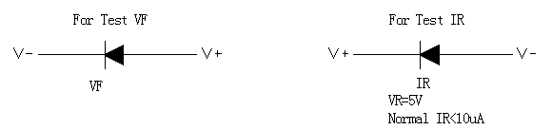

11.6.3 顺向电压VF过高或反向电压VR过高，均会损坏LED.
If the forward voltage VF is too high or the reverse voltage VR is too high, the LED will be damaged.

11.6.4 点亮或测试LED时，加在LED两端的反向电压不得高于5V，否则容易击伤LED.
When lighting or testing the LED, the reverse voltage added on both ends of the LED shall not be higher than 5V, otherwise it is easy to damage the LED.

11.6.5 LED发光颜色会随着工作电流不同而有少许变化,建议设计时考虑电阻与LED串联使用。
LED luminous color will vary slightly with the working current. It is suggested that resistance and LED should be used in series in the design
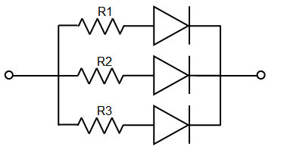

11.6.6 LED容易因为自身的发热和环境的温度改变而改变，温度升高会降低LED发光效率，影响发光颜色在设计时应充分考虑散热问题。
LED is easy to change due to its own heat and changes in the temperature of the environment. The increase in temperature will reduce the luminous efficiency of LED, which will affect the luminous color. Heat dissipation should be fully considered in the design

